ONEWAY SA BY HOS
/STATISTICS DESCRIPTIVES HOMOGENEITY WELCH
/PLOT MEANS
/MISSING ANALYSIS.

Oneway

Notes
Output Created |  | 05-May-2019 23:40:29
Comments
Input | Active Dataset | DataSet0
Input | Filter | <none>
Input | Weight | <none>
Input | Split File | <none>
Input | N of Rows in Working Data File | 30
Missing Value Handling | Definition of Missing | User-defined missing values are treated as missing.
Missing Value Handling | Cases Used | Statistics for each analysis are based on cases with no missing data for any variable in the analysis.
Syntax |  | ONEWAY SA BY HOS  /STATISTICS DESCRIPTIVES HOMOGENEITY WELCH  /PLOT MEANS  /MISSING ANALYSIS.
Resources | Processor Time | 00 00:00:00.156
Resources | Elapsed Time | 00 00:00:00.153

[DataSet0]

Descriptives
 | N | Mean | Std. Deviation | Std. Error
Between 7-5 hours of sleep | 8 | 21.1250 | 6.51235 | 2.30246
Between 7-9 hours of sleep | 8 | 31.7500 | 18.21891 | 6.44136
Less than 5 hours of sleep | 7 | 27.2857 | 12.57927 | 4.75452
More than 9 hours of sleep | 7 | 26.2857 | 26.14520 | 9.88196
Total | 30 | 26.6000 | 16.74062 | 3.05640

Descriptives
 | 95% Confidence Interval for Mean |  | Minimum | Maximum
 | Lower Bound | Upper Bound | Minimum | Maximum
Between 7-5 hours of sleep | 15.6805 | 26.5695 | 14.00 | 35.00
Between 7-9 hours of sleep | 16.5186 | 46.9814 | 15.00 | 62.00
Less than 5 hours of sleep | 15.6518 | 38.9196 | 15.00 | 50.00
More than 9 hours of sleep | 2.1054 | 50.4660 | 5.00 | 67.00
Total | 20.3490 | 32.8510 | 5.00 | 67.00

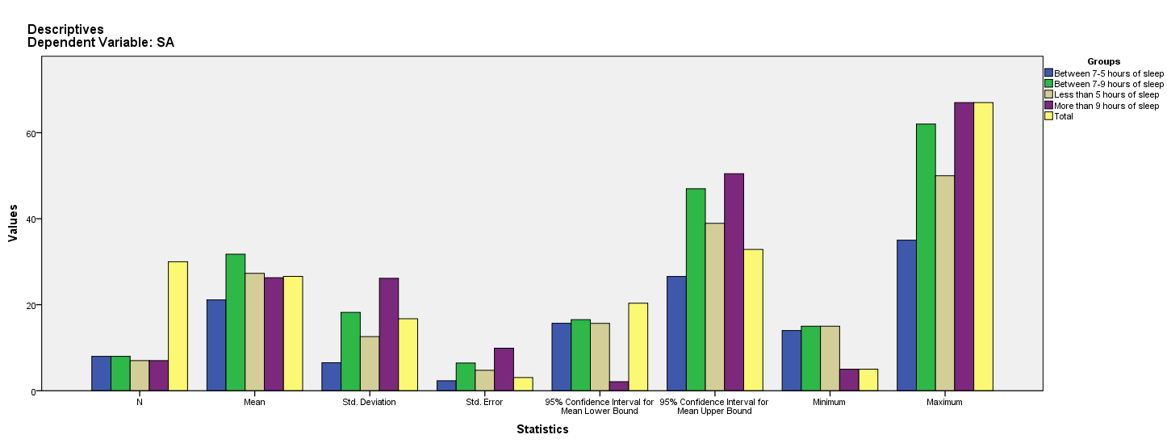

Test of Homogeneity of Variances
SA
Levene Statistic | df1 | df2 | Sig.
4.864 | 3 | 26 | .008

ANOVA
SA
 | Sum of Squares | df | Mean Square | F | Sig.
Between Groups | 455.968 | 3 | 151.989 | .515 | .675
Within Groups | 7671.232 | 26 | 295.047
Total | 8127.200 | 29

Robust Tests of Equality of Means
SA
 | Statisticª | df1 | df2 | Sig.
Welch | 1.026 | 3 | 12.475 | .414
a. Asymptotically F distributed.

Means Plots

